*******FOR IMMEDIATE RELEASE******
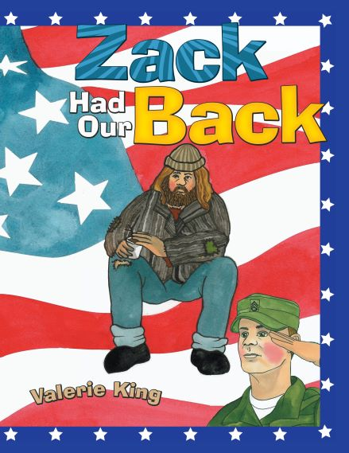
Valerie King
571-379-2191,571-393-8490
readzack4777s@gmail.com
https://www.zackhadourback.com/

ZACK HAD OUR BACK ACQUIRED BY CINCINNATI PUBLIC LIBRARY
BOOK AND MOVIE ‘THE PUBLIC’ MAKE POWERFUL STATEMENT
ABOUT VETERANS, HOMELESS & PUBLIC LIBRARIES
RESTON,VA, FEBRUARY 15, 2022— Zack had our Back, by Valerie King, has been acquired by the Cincinnati Public Library system. The book about the surprising encounter between an unkempt, homeless veteran and a young girl observing him, unfolds in rhyme and reveals the veteran’s service to country, the reasons behind his life on the streets, a surprise about his character, and a lesson about judgement and superficial appearances.
The addition of the book to the collection in conjunction with ‘The Public”, a movie about the homeless directed by Emilio Estevez and filmed at the Libraries’ Vine Street location, makes a powerful statement about public libraries as the last social safety net available to the vulnerable. The book amplifies these deficiencies in the face of military sacrifice and may serve as a reminder to young readers not to repeat mistakes of the past as they relate to the honor and care of returning veterans.
Zack had our Back is available through Amazon, book culture, Walmart, Barnes & Noble, eBay, Ingram, the Reston, Virginia Regional Library and Cincinnati, Ohio Public Libraries.

###

