*******FOR IMMEDIATE RELEASE******
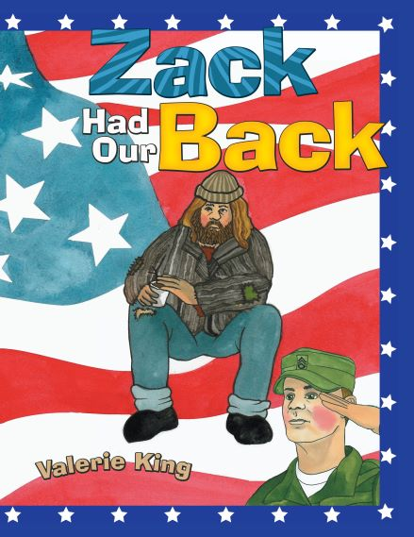
Valerie King
2085 Cobblestone Lane
Reston, VA 20191
Valerie.king54@gmail.com
https://www.zackhadourback.com/

CHILDREN’S BOOK ‘ZACK HAD OUR BACK’ DELIVERS INSIGHTS ON TOXICITY OF MISPERCEPTION

RESTON,VA, OCTOBER 8, 2018— Zack had our Back, is the story of the didactic moments that occur between an unsettling, homeless veteran and a curious young girl. In a twenty--eight page fiction format for ages 3-8, the story unfolds in short rhyming verse accompanied by colorful illustrations to accommodate young attention spans while revealing the homeless veteran’s service to country, the reason behind his life on the streets, and a surprise about his character. This delightful story occupies an unusual niche in children’s literature for its delicate handling of difficult but important subject matter and its resonance with both young and old. Zack had our Back is published and distributed worldwide through Archway Publishing, an imprint of Simon & Schuster, Amazon and others in a variety of formats.
###

